**Electrodynamics HW Problems**

**01 – Current & Resistance**

1. A, B & J-fields
2. Current density/drift velocity
3. Spherical resistor
4. Coaxial cable
5. Resistance of a rectangular slab
6. General formula for resistance

**1.01. A, B & J-fields** [Dubson SP12, Pollock FA11]

Suppose the vector potential in a region of space is given by:



**(a)** What are the units of the given constants *a* and *A0* ?

- Determine the magnetic field from this vector potential via .

- Determine the current density from the magnetic field.

**Note:** The equation given is in Cartesian coordinates, but you may use another coordinate system if that would make your calculations easier. Briefly but clearly justify your choice!

**(b)** Separately sketch the **A, B**, and **J** fieldsusing any representation you like. Briefly, for EACH of the three plots, also use English words to describe what they look like.

**(c)** Integrate the current density to mathematically show that the total current flowing through *any* infinite plane parallel to the *x-y* plane is zero. Then, give a simple argument (without doing any formal integral) why you could have known before calculating that this must be the case.

**(d)** Calculate the divergence of the current density **J**. What does the value of the divergence imply, in terms of the *continuity equation*?

- Does this set of **A** - **B** - **J** fields strike you as an unphysical mathematical exercise, or can you imagine some physical system or electronic device which might at least be approximately described/represented by the equations in this problem?   
Briefly, discuss.

**1.02. Current density/drift velocity** [Dubson SP12]

**(a)** Prove that the current density is given by , where *n* is the number density (number per volume) of charge carriers, *q* is the charge of each carrier, and **v** is the average velocity of the charge carriers, which is called the “drift” velocity.

**(b)** In most metals, there is one conduction electron per atom, and the distance between adjacent atoms is about 0.2 nm. Consider a metal wire with 1 mm diameter, carrying a current of 10 A (these numbers are typical of wires in the walls of your home). Compute the drift velocity of the electrons in this wire.

**1.03. Spherical resistor** [Dubson SP12, Pollock FA11, Kinney SP11]

a

b

V0

⬧

A region between two concentric metal spherical shells (with radius *a* and *b*, respectively) is filled with a weakly conducting material of conductivity . Assume the outer shell is electrically grounded, and a battery maintains a potential difference of  between the two shells. [*In this problem, please don't confuse conductivity*  *with surface charge density! Also, for this problem, ignore any dielectric properties of this weakly conducting material*.]

**(a)** What total current *I* flows between the shells? Also, what is the total resistance, *R*, of the weakly conducting material between the shells?

**(b)** Re-express your final answers (for *I* and *R*) in part (a), in terms of the total capacitance *C* for this same geometric arrangement of two concentric shells.

**(c)** Suppose the battery that was maintaining  between the concentric spheres were suddenly disconnected (at *t* =0). At *t* =0, the voltage difference between inner and outer spheres is thus , but there is no battery to *maintain this* any more. Describe qualitatively what you expect happens over time. Then, calculate the voltage, and the current that flows, between the two shells as a function of time, i.e., find *V(t)* and *I(t*). Does your calculation agree with your qualitative prediction? Discuss whether/how your answers depend on the specific (spherical) geometry of this situation.

**(d)** For the situation of part (c), calculate the original total energy stored in the spherical capacitor. By integrating Power (= V*I), confirm that the heat delivered to the resistance is equal to the energy lost by the spherical capacitor.

**(e)** Going back to the setup in part (a): Adapt your equation for the resistance between the two concentric conducting shells to the situation where a conducting sphere of radius *a* is embedded in a large uniform volume with conductivity , and held at a potential of  with respect to some boundary very far away. What would be the resistance for this arrangement?

Now use this in the following real-world application: take a single *spherical conductor* of radius a1, and lower it by a conducting wire into a large, deep, body of water. Do the same with a second conducting sphere of radius a2, located a significant distance away. (What does "significant" mean here?) Set up a fixed potential difference of  between the two spheres, perhaps with a car battery. Describe what electrical quantit(ies) you would measure to determine the resistivity, ρ, of the water in which these two spheres are immersed. (Include an explicit formula telling how you would deduce ρ from what you measured) Putting in plausible numbers, do you think this experiment could work in practice?

**1.04. Coaxial cable** [Pollock FA11]

A coaxial cable consists of an inner conducting cylinder with radius *a*, and a conducting outer cylindrical shield with inner radius *b*. The length of the cylindrical cable is *L*.

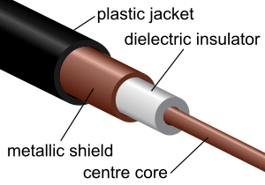Coaxial cables are ordinarily used to transmit high frequency electromagnetic signals, and the region between the two cylinders is ordinarily filled with a good dielectric insulator. For this problem we will use this geometry to create a resistor by placing weakly conducting materials between the two metal conductors. A voltage difference *V*0 can be maintained between the two conductors using a battery.

**(a)** Calculate the resistance *R* of the coaxial resistor between the inner core, and the outer shield, if the material between the two conductors has resistivity ρ. [Your answer should be in terms of the given quantities: at most, a, b, L, , *V*0, and/or fundamental constants.]

Explicitly discuss as many ways as you can think of to c*heck* that your result is physically reasonable, beyond merely "I got what Griffiths got in Example 7.2". Describe (words and formulas) what the vector current density **J** resulting from your solution looks like. Show that it satisfies the steady state continuity equation (Griffiths, Eq. 5.29) by having zero divergence. Why is this necessary physically?

**(b)** Suppose the cylindrical region between radii *a* and *b* is now subdivided into two uniform parts (divided at some intermediate radius *c*, with *a* < *c* < *b*). The inner portion (between radii *a* and *c*) is uniformly filled with a material of resistivity . The outer portion (between radii *c* and *b*) has (different) resistivity .

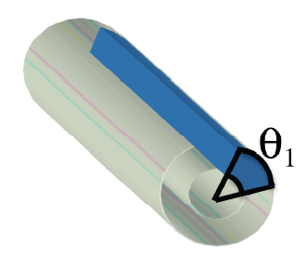Calculate the total resistance of this coaxial setup in terms of given quantities.   
How can your answer be interpreted in terms of what you learned about resistors in introductory E&M?

**(c)** Suppose instead that we create a "pie shaped" conductor (see figure). Basically, take the long cylindrical coax (still inner radius *a*, outer radius *b*), but fill only a pie-shaped region of angular extent θ, with the weak conductor (resistivity ). The remainder of the angular region is completely non-conductive, so we now only have this "pie-slice of material" leading from the inner to outer radii. Calculate the resistance of this coaxial pie-resistor, from inner core to outer shield.

***Extra Credit:*** Replace the nonconductive region in part (c) with a conductive material (resistivity ρ2.) ngle of ) What is the total resistance R from inner core to outer shield? How can your answer be interpreted in terms of what you learned about resistors in introductory E&M?

**1.05. Resistance of a rectangular slab** [Dubson SP12]

Consider a parallel-plate capacitor attached to a battery of constant voltage V0 as shown in the diagram below. The plates are separated by a distance *d*. The plates are square with area *L*2, where *L* >> *d*, so that the edge effects are negligible (the diagram exaggerates the dimension *d*). The space between the plates is filled with a weakly conducting material that has a *non-constant* conductivity, a conductivity that depends on position *x* between the plates as , where σ0 and  are constants.

**(a)** Consider the following quantities: current *I*, current density , electric field , and voltage *V*. Which of these quantities is constant, independent of position, in the space between the plates? Explain your choices.

**(b)** Solve for the electric field between the plates in terms of the battery voltage V0 and the other known quantities. Make a qualitative sketch of the magnitude of the field vs. position *x*.

**(c)** Is the charge density ρ between the plates *zero* or *non-zero*? If zero, explain why. If non-zero, derive an expression for the charge density ρ between the plates in terms of the known quantities in the problem, and check that your answer makes sense by considering the limit where , i.e. the limit of **constant** conductivity. Explain briefly.

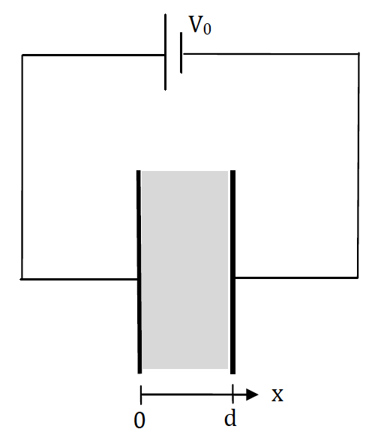**(d)** Derive an expression for the resistance of the material between the plates. Show that your expression makes sense by considering the limit where , i.e. the limit of constant conductivity.

**1.06. General formula for resistance** [Kinney SP11]

The simplest type of resistor has conducting contacts placed so that the current flows through a constant cross section of the resistive material. Given such a resistor of cross sectional area *A* (perpendicular to the desired current flow direction), and length *L* (along the direction of desired current flow), derive a general formula to calculate the total resistance *R* in terms of the dimensions and the resistivity ρ. Be sure to make a sketch to define your variables.